B.Sc. in Business Computing
Software Design Patterns
Assessment 1
1. Using Creational Patterns: Abstract Factory pattern
For this exercise, we will be using the code of the original AutoSearch Swing application that we looked at for the Prototype exercise last week. This searches for cars or SUVs which meet certain criteria and display the details for the chosen car. At the moment we have two Car and SUV interfaces which are implemented by parallel Luxury and NonLuxury concrete classes.
At the moment, the user selects a category of vehicle, a type of vehicle, and a brand from a series of combo boxes in the dialog. If there is an appropriate vehicle meeting these criteria, then its details are displayed, if not then the details are empty.

The code in the action listener is currently extremely complex and requires multiple nested if statements to select an appropriate item to display. Try to simplify this code by introducing the Abstract Factory pattern. This will require a VehicleFactory abstract factory and two concrete factories for luxury and non-luxury vehicles that can be used to abstract the creation process. You should use the Singleton pattern to ensure that only a single instance of each concrete factory can be created.
You will find the code for AutoSearch, Car, LuxuryCar, NonLuxuryCar, SUV, LuxurySUV and NonLuxurySUV in the AbstractFactoryCode.zip file. Submit your restructured classes in a AbstractFactorySolution.zip file.
(50 marks)
2. Using Structural Patterns: Adapter pattern
We have a class available to us called RealisticBehaviour.java which simulates the behaviour of a rocket based on various parameters supplied to it (its burn area, burn rate, fuel mass and total mass) and allows the total burn time to be calculated and displayed, as well as calculating fuel mass and thrust of the rocket at any specific point in time during the burn time.
We currently have an interface called MissileSimulator which defines a set of methods which simulate the flight and timing of missiles. The interface is used by a class called RocketController that explores the effects of launching a rocket with various parameter values using either a simple simulator or an advanced one.
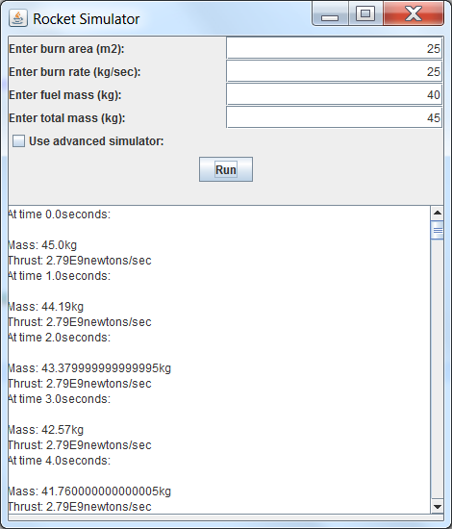
The methods in the MissileSimulator interface have similar semantics to corresponding methods in RealisticBehaviour.java but their parameters and names are different. In addition, the simulator keeps an internal clock and occasionally updates simulated objects by calling a setSimulatedTime method. The current simulator uses a class called SimpleMissile.java, whose interface conforms to the MissileSimulator interface but whose physics are less realistic than those of RealisticBehaviour.java. You do not need to change the code of either SimpleMissile or RealisticBehaviour - you are taking the code as given.
You will find the code for RocketController, RealisticBehaviour, MissileSimulator and SimpleMissile in the AdapterCode.zip file.
You need to create code for the following:
- a class adapter called ClassMissileAdapter.java which will be a subclass of RealisticBehaviour but which will implement the MissileSimulator interface, mapping the interface methods onto its superclass's methods.
- an object adapter called ObjectMissileAdapter which will be a subclass of SimpleMissile but which has a RealisticBehaviour object as a component.
and insert code into RocketController that uses instances of each of those adapters as the "advanced" option, i.e. you should have two versions of RocketController, one using the class adapter and the other the object adapter.
Submit your restructured classes in a AdapterSolution.zip file.
(50 marks)

